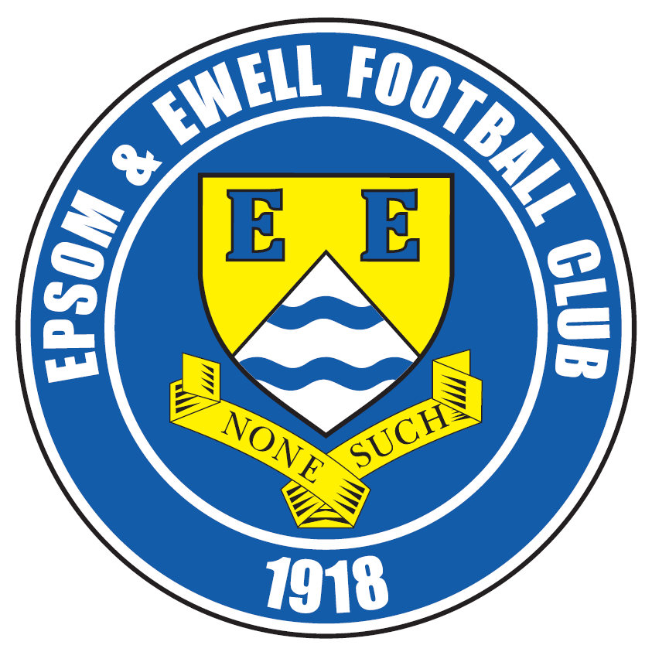 | Epsom & Ewell F.C.  3  v  Windsor F.C.  Saturday, 8th August 2015
Good afternoon! We congregate back at High Road for our opening League game of the season and welcome the players and officials of Windsor F.C. along with our match officials and of course our own regular supporters.

This is our fourth season ground sharing here at Chipstead F.C. and once again we thank them for their hospitality. Despite having been twenty two years away from our home borough, hopes are still high that we can return, although you the supporters can also help us out by sponsoring our matches and players for the season. The new lists appear in today’s programme.

Last season’s fixtures between the clubs were both won convincingly away from home. Windsor won 5-0 here in January, although a team weakened by suspensions that day were set back by an early red card and faded in the final fifteen minutes. We showed what we were really capable of in the return match in April when winning 3-0 at Stag Meadow, although it could also be argued that Windsor had other matters to distract them that day, playing in the Berks & Bucks Senior Trophy three days later which they won. Unfortunately, we continue to deal with the legacy of our club record 11 sending offs last season as two of our squad are suspended for today’s match, but hopefully we can rise above it despite this tough opening fixture.

In fact, the Stags were one of only six clubs who finished above us last year, and are regular challengers, but who are the sides to watch this season? Apart from us of course!

As always in this League it is tough to call. Camberley now have the services of former Windsor striker Robert Lazarczuk, whilst Hartley Wintney have taken on the Manager and many of the impressive Cove team from last season, so when added to the players they already had, these may be the two teams to watch. However, I’m sure Windsor and Ashford Town (Mx) will both be there or thereabouts, as will Badshot Lea, while I haven’t even mentioned the two relegated teams AFC Hayes and Redhill. We will get a good look at the Lobsters as we travel there on Tuesday. It is clear that another competitive and challenging season awaits us!

Following our opening two League matches we face another challenge in the F.A. Cup as Erith & Belvedere visit us here next weekend. They reached the Quarter-Final of the F.A. Vase last season and are one of the toughest sides we could have drawn. However, the carrot of a home tie with Carshalton Athletic awaits the winners so I hope we have a real go at them. Please note that this match will be played next Sunday, 16th August as Chipstead are at home on the Saturday.

Enjoy the game!

Rich

Did you know we are now on Facebook? www.facebook.com/epsomandewellfc
And we are still on Twitter @EEFCOfficial

Cover photos by Gemma Jarman

Here are Alex McKay’s two goals against Windsor from our 2-1 win here on 1st April 2014. The second goal was a bullet header in injury time which was unforgettable for both sets of supporters, as Windsor had only just equalised!


Cherry Red Records
Combined Counties League
Premier Division Final Table 2014/15
 | P | W | D | L | F | A | Pts | GD | H | A
Molesey | 40 | 30 | 1 | 9 | 108 | 36 | 91 | +72 | 1-3 | 0-5
Camberley Town | 40 | 26 | 8 | 6 | 86 | 33 | 86 | +53 | 2-4 | 0-1
Ashford Town (Mx) | 40 | 25 | 5 | 10 | 94 | 54 | 80 | +40 | 2-4 | 3-1
Cove | 40 | 23 | 8 | 9 | 89 | 65 | 77 | +24 | 2-2 | 0-1
Windsor | 40 | 23 | 4 | 13 | 96 | 57 | 73 | +39 | 0-5 | 3-0
Spelthorne Sports | 40 | 20 | 6 | 14 | 73 | 60 | 66 | +13 | 4-3 | 3-0
Epsom & Ewell | 40 | 19 | 4 | 17 | 77 | 68 | 61 | +9 | - | -
Badshot Lea | 40 | 18 | 5 | 17 | 74 | 58 | 59 | +16 | 3-0 | 2-4
Hartley Wintney | 40 | 16 | 5 | 19 | 56 | 77 | 53 | -21 | 2-1 | 1-2
Farnham Town | 40 | 15 | 7 | 18 | 77 | 99 | 52 | -22 | 2-4 | 2-0
Colliers Wood United | 40 | 15 | 6 | 19 | 75 | 71 | 51 | +4 | 2-1 | 2-3
Horley Town | 40 | 13 | 9 | 18 | 70 | 88 | 48 | -18 | 2-2 | 0-1
Knaphill | 40 | 14 | 6 | 20 | 58 | 81 | 48 | -23 | 1-2 | 4-1
Westfield | 40 | 12 | 11 | 17 | 61 | 68 | 47 | -7 | 3-1 | 0-4
Raynes Park Vale | 40 | 13 | 8 | 19 | 50 | 65 | 47 | -15 | 0-1 | 2-0
Bedfont Sports | 40 | 14 | 5 | 21 | 52 | 74 | 47 | -22 | 0-1 | 2-0
Guildford City | 40 | 14 | 4 | 22 | 76 | 100 | 46 | -24 | 4-1 | 3-1
Mole Valley SCR | 40 | 13 | 6 | 21 | 62 | 94 | 45 | -32 | 1-0 | 5-2
Hanworth Villa | 40 | 12 | 8 | 20 | 58 | 73 | 44 | -15 | 1-1 | 5-2
Chertsey Town | 40 | 12 | 7 | 21 | 66 | 94 | 43 | -28 | 1-2 | 2-1
Frimley Green | 40 | 9 | 5 | 26 | 60 | 103 | 32 | -43 | 0-0 | 5-1

Lucky Day? – 8th August
Played 1 - Won 1 Drawn 0 Lost 0 - F 2 A 0 - PPG 3.00 - Perfect
Club record against Windsor (incl Windsor & Eton)
Played 43 - Won 17 Drawn 11 Lost 15 - F 81 A 79 - PPG 1.40 - Average
Last visit
Saturday 3rd January 2015 - Lost 0-5 - Combined Counties League

Glyn Mandeville

Good afternoon everyone and a big welcome to the supporters, players and staff of Windsor F.C. I hope you have a good day with us but not that good a day!

I very much look forward to seeing how we fare this season with a number of players leaving and many good new players coming in. I am looking forward to working with them.

Team spirit is good as we have seen in pre-season. This has gone well for us and with some good things to work on, me and my staff are looking forward to doing so this season.

I believe it's going to be another tough league and wish all our lads the very best of luck.

Hope you enjoy the season and thank you for your continued support.

Yours in football.

Manders

Sam Currie

Good afternoon we hope you have had a nice summer break and we welcome the players, coaching staff and supporters of Windsor F.C. and of course our own to High Road.

You join us as we venture into what we hope will be an exciting new season.

The boys that have come in this summer have already improved the quality in depth of an already strong squad and the heathy competition for places, alongside the expected work rate and ethic, which sees us very much looking forward to the new campaign.

Pre-season has been largely a success with only one defeat to Croydon in six games against some tough opposition, and against Croydon we were hampered by a lack of players available against a well organised side.

In particular the final game of pre-season left us in a buoyant mood on Tuesday night - and showed just what we are capable of producing against a Ryman League side. Along with the huge bonus of picking up the Dave Wilson trophy - a name that is rightly etched into our club’s history for the time and effort he dedicated to The Salts.

We are grateful for your support as always and we hope you enjoy your afternoon.

Sam

Pete Beddoe

Today is the start of the new competitive season which all at EEFC have been eagerly anticipating. Yet for our manager Glyn, his loyal assistants and players it really started a month ago with pre-season training and friendlies.

The pre-season friendlies culminated in an excellent win over our ever helpful landlords Chipstead FC in a match in memory of our still so missed former Secretary, Dave Wilson. It is always good to beat as team at a higher level. The goals came from an excellent strike from new winger Reisse Griffin and the usual contribution from Kyle.

We thank Chipstead FC for providing the facilities for this match and for all their help on the day. All at EEFC would like to thank especially Alan (“Coops””) for all the help he provided on Tuesday and and on every match day. By the time you read this he’ll be on his way to a new life abroad and we wish him well.

Another highlight of the pre-season was the match against Hoddesdon Town, whom we beat 5-3 to gain some satisfaction after our only meeting in 1975 when we lost to them at Wembley in the first ever F.A. Vase Final. We do hope it won’t be 40 years before we play them again! As participants, representatives of Hoddesdon Town & EEFC attended the 40th anniversary of that final for this year’s final between Glossop North End and North Shields as guests of the F.A. It was a day to remember.

It is also worth noting that the players enjoyed a very successful Presentation Evening at the Epsom Common Working Men’s Club on Epsom Common at the end of the season.

There are some very interesting early league matches at the beginning of the season, one of which will against Sutton Common Rovers who will be playing at Sutton United. The players will be able to play on the synthetic pitch which has just been laid there and it will be useful to find out their views on playing on this surface as this is an option on a relocated venue back in the Borough. The relocation remains our prime target off the field and hopefully there will be more progress this season.

Apart from the League matches we are hosting Erith & Belvedere in the Extra Preliminary round of the Emirates F.A. Cup on Sunday 16th August. Please come along in vast numbers to give the team our support. And of course it’s always one match at a time. So we musn’t anticipate the next possible tie.

From what I’ve seen the team spirit amongst the players is even better than last season so let’s all enjoy the coming term and support the team. We rely on our loyal supporters. Just to reiterate this, one way of supporting the team is to sponsor matches and all contributions will be gratefully received by our hard working Treasurer, Steve Dyke. Of course if any of you have any issues or concerns about the Club and its future please contact any member of the Committee and we’ll do our best to deal with them.

Finally and most importantly our Club President, Stella Lamont, sends her best wishes to everyone connected with the Club. She regrets not being able to get to matches, but still follows our performance on the field avidly.

Peter

First Eleven Appearances - (max 49)
Name | Debut | 2014/15 |  |  |  | Career Totals
Name | Debut | App | Sub | Total | Goals | App | Sub | Total | Goals
BROWN Oshane | 30/08/2014 | 2 | 0 | 2 | 0 | 2 | 0 | 2 | 0
BURNS Robbie | 14/08/2007 | 3 | 2 | 5 | 0 | 205 | 16 | 221 | 121
COOPER-SMITH Daryl | 03/01/2015 | 9 | 3 | 12 | 6 | 9 | 3 | 12 | 6
CURRIE Sam | 04/08/2012 | 14 | 4 | 18 | 0 | 108 | 9 | 117 | 2
DEAN Dan | 02/08/2014 | 36 | 1 | 37 | 0 | 36 | 1 | 37 | 0
DEWAR Ali | 29/10/2011 | 5 | 6 | 11 | 3 | 55 | 35 | 90 | 10
DOUGLIN Karl | 03/08/2013 | 1 | 0 | 1 | 1 | 41 | 3 | 44 | 14
DOWNS Carl | 17/09/2011 | 4 | 1 | 5 | 0 | 94 | 13 | 107 | 2
EACOTT Michael | 02/08/2014 | 46 | 0 | 46 | 0 | 46 | 0 | 46 | 0
FARRELL Matt | 02/08/2014 | 41 | 3 | 44 | 7 | 41 | 3 | 44 | 7
FERDINANDO Matt | 20/09/2014 | 27 | 4 | 31 | 6 | 27 | 4 | 31 | 6
FRANKLIN Ben | 03/03/2015 | 1 | 0 | 1 | 0 | 1 | 0 | 1 | 0
GAFFNEY Luke | 16/08/2014 | 10 | 1 | 11 | 0 | 10 | 1 | 11 | 0
GANNON Thomas | 28/03/2015 | 0 | 1 | 1 | 0 | 0 | 1 | 1 | 0
HARPER Tommy | 15/04/2014 | 1 | 0 | 1 | 0 | 2 | 1 | 3 | 0
HAYWARD Ben | 07/03/2007 | 7 | 0 | 7 | 0 | 243 | 28 | 271 | 18
HOADLEY Harry | 27/08/2011 | 6 | 2 | 8 | 0 | 7 | 2 | 9 | 0
HOUGH Kyle | 14/08/2007 | 42 | 3 | 45 | 34 | 296 | 15 | 311 | 171
JARMAN Mark | 08/08/2009 | 5 | 5 | 10 | 0 | 136 | 51 | 187 | 76
KAVANAGH James | 04/04/2015 | 0 | 4 | 4 | 0 | 0 | 4 | 4 | 0
MANDEVILLE Glyn | 25/04/2015 | 0 | 1 | 1 | 0 | 0 | 1 | 1 | 0
MARVELL Dale | 15/01/2000 | 11 | 5 | 16 | 5 | 261 | 45 | 306 | 85
MCGREGOR Alex | 08/08/2009 | 15 | 2 | 17 | 1 | 172 | 56 | 228 | 27
MCKAY Alex | 20/12/2008 | 20 | 4 | 24 | 1 | 85 | 26 | 111 | 8
MURPHY George | 28/03/2013 | 25 | 2 | 27 | 1 | 66 | 6 | 72 | 3
MUTIMA Lionel | 05/08/2014 | 4 | 2 | 6 | 0 | 4 | 2 | 6 | 0
NELMES Elliott | 05/08/2014 | 2 | 0 | 2 | 0 | 2 | 0 | 2 | 0
PANAYI Anthony | 14/11/2010 | 40 | 2 | 42 | 0 | 167 | 16 | 183 | 4
PANAYIOUTOU Savvas | 03/01/2015 | 16 | 3 | 19 | 3 | 16 | 3 | 19 | 3
ROBINSON Matt | 01/12/2012 | 20 | 2 | 22 | 4 | 21 | 5 | 26 | 5
ROBINSON Sam | 22/10/2011 | 30 | 1 | 31 | 8 | 54 | 4 | 58 | 13
ROWE Steve | 27/08/2011 | 19 | 1 | 20 | 0 | 24 | 2 | 26 | 0
SHAW Ollie | 20/09/2014 | 0 | 10 | 10 | 0 | 0 | 10 | 10 | 0
SMITH Matt | 08/08/2009 | 0 | 1 | 1 | 0 | 91 | 43 | 134 | 10
SMITH Taylor | 02/08/2014 | 13 | 2 | 15 | 7 | 13 | 2 | 15 | 7
TANTON Matt | 02/08/2014 | 18 | 4 | 22 | 1 | 18 | 4 | 22 | 1
TAYLOR James | 26/08/2013 | 39 | 2 | 41 | 2 | 56 | 8 | 64 | 3
VAN GELDER Julian | 12/09/2006 | 0 | 1 | 1 | 0 | 0 | 2 | 2 | 0
WHITE Sean | 02/08/2014 | 6 | 13 | 19 | 3 | 6 | 13 | 19 | 3
YOUNG Conor Jack | 07/03/2015 | 1 | 0 | 1 | 0 | 1 | 0 | 1 | 0
Own Goal |  |  |  |  | 1

Opening League and Cup Fixtures
Combined Counties League – Friday 7th August
Sutton Common Rovers | V | Colliers Wood United
Combined Counties League – Saturday 8th August
Ashford Town (Mx) | V | AFC Hayes
Bedfont Sports | V | Knaphill
Camberley Town | V | Horley Town
Chertsey Town | V | Guildford City
Epsom & Ewell | V | Windsor
Farnham Town | V | Chessington & Hook United
Hanworth Villa | V | Badshot Lea
Hartley Wintney | V | Redhill
Raynes Park Vale | V | Cove
Westfield | V | Spelthorne Sports
Combined Counties League – Monday 10th August
Sutton Common Rovers | V | Raynes Park Vale
Combined Counties League – Tuesday 11th August
AFC Hayes | V | Hanworth Villa
Badshot Lea | V | Hartley Wintney
Chessington & Hook United | V | Ashford Town (Mx)
Horley Town | V | Knaphill
Redhill | V | Epsom & Ewell
Spelthorne Sports | V | Camberley Town
Windsor | V | Bedfont Sports
Combined Counties League – Wednesday 12th August
Colliers Wood United | V | Chertsey Town
Cove | V | Westfield
Guildford City | v | Farnham Town
F.A. Cup Extra – Preliminary Round – Saturday 15th August
AFC Hayes | V | Flackwell Heath
Arundel | V | Raynes Park Vale
Badshot Lea | V | Camberley Town
Berkhamsted | V | Hanworth Villa
Binfield | V | Westfield
Chessington & Hook United | V | Crowborough Athletic
Chinnor | V | Hartley Wintney
Colliers Wood United | V | Eastbourne Town
Cove | V | Shrivenham
Opening League and Cup Fixtures
F.A. Cup Extra – Preliminary Round – Saturday 15th August
Croydon | V | Sutton Common Rovers
Horley Town | V | Wick & Barnham United
Knaphill | V | Highworth Town
Potton United | V | Bedfont Sports
Reading Town | V | Chertsey Town
Redhill | V | Pagham
Spelthorne Sports | V | Stotfold
Tadley Calleva | V | Guildford City
Thame United | V | Farnham Town
Wellingborough Town | V | Ashford Town (Mx)
Windsor | V | AFC Dunstable
F.A. Cup Extra – Preliminary Round – Sunday 16th August
Epsom & Ewell | V | Erith & Belvedere
Combined Counties League – Tuesday 18th August
All provisional and dependent on any F.A. Cup replays there may be
Ashford Town (Mx) | V | Spelthorne Sports
Bedfont Sports | V | Sutton Common Rovers
Camberley Town | V | Cove
Chertsey Town | V | Horley Town
Epsom & Ewell | V | Colliers Wood United
Farnham Town | V | Badshot Lea
Hanworth Villa | V | Windsor
Hartley Wintney | V | Guildford City
Knaphill | V | Redhill
Raynes Park Vale | V | Chessington & Hook United
Westfield | V | AFC Hayes
Combined Counties League – Saturday 22nd April
AFC Hayes | V | Knaphill
Bedfont Sports | V | Raynes Park Vale
Chessington & Hook United | V | Chertsey Town
Colliers Wood United | V | Hartley Wintney
Cove | V | Ashford Town (Mx)
Guildford City | V | Westfield
Horley Town | V | Hanworth Villa
Redhill | V | Camberley Town
Spelthorne Sports | V | Farnham Town
Sutton Common Rovers | V | Epsom & Ewell
Windsor | V | Badshot Lea

From behind the goal
Chipstead 1-2 Epsom & Ewell
Dave Wilson Trophy XI - Tuesday 4th August 2015

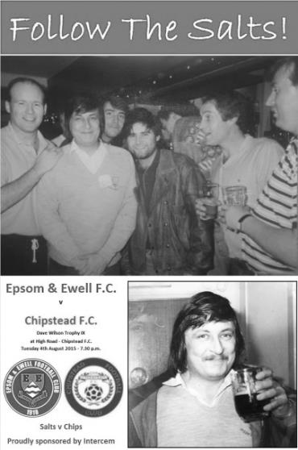
Salts retain Memorial Trophy with committed display

The ninth Dave Wilson Memorial Trophy took place on a chilly evening at High Road with our boys claiming the honours with a come from behind 2-1 win, leaving Sam Currie to pick up the trophy for the second year in a row; the club's third win in total.

After the shortage of players at Croydon on Saturday many were available and we were able to use six substitutes. It was just as well as we picked up three hopefully minor injuries during the match. However, this gave many players the opportunity to stake their claims for starting positions and a fully committed display, particularly in the second half resulted in a well-earned win.

It was a bit scary in the first few minutes though. From the kick off it looked as though our landlords would run straight through and score but we averted the danger and another couple of near misses had me wondering whether we had left the dressing room yet, but we settled down and the remainder of the first twenty minutes was very even with not a lot of danger at either end.

The first real chance came on that twenty minute mark when a deep right wing cross from the overlapping Currie was headed back across goal by Matt Ferdinando and Daryl Cooper-Smith sent a low shot that was well turned around the post by the Chipstead keeper. From a Ferdinando cross moments later, Rob Hendrie headed a clear chance just over the bar when well-positioned.

We had to rearrange things after 23 minutes when Craig Hastings received an injury and James Taylor came on to replace him. Within a couple of minutes we nearly conceded as a speculative chip from just inside the box drifted over everyone and bounced back to Michael Eacott off the far post.

The game began to open up a little and the balance of possession started to swing our way for the first time. Lady luck was not kind to our opponents moments later as their keeper made another fine save from a first time low strike by Cooper-Smith from the edge of the box in the 32nd minute, but jarred his shoulder badly as he landed and had to go to hospital. With no substitute keeper available his place was taken by an outfield player.

From this point we started to grow in confidence. Cooper-Smith did well to reach a Ferdinando corner but the header was just over the bar before Reisse Griffin had a couple of good chances, the first on a break through and the second after a Matt Farrell cross had been half cleared but he dragged both shots wide of the far post. In the seventh minute of

first half injury time we were made to pay for it. Eacott made a great save from a far post downward header, but within seconds we had conceded a free kick out wide which Eacott was unable to hold on to and the loose ball was knocked into the net with no time left to restart the game before the interval whistle was blown.

This was harsh on our boys but we just picked ourselves up and if anything stepped up another gear in the second half, closing the opposition down at every opportunity. Of course it also helps when you are able to put Kyle Hough onto the field and our late arriving striker took the field in place of Ferdinando with Hendrie moving onto the left flank for a while before he was replaced by the returning Alex McGregor.

We were level in the 59th minute. A right wing cross from Rhys North was deflected into the path of Griffin who drilled his shot in at the near post from a narrow angle. Maybe a regular keeper would have been positioned nearer his front post, but it was still a powerful strike and flew into the net. Five minutes later Griffin turned provider with a slide rule pass to Hough who saw the gap and tucked the ball left footed into the keeper's left hand corner just inside the near post from about 15 yards out for what proved to be the winner. He nearly made it 3-1 five minutes from time when he beat his man and cut in on goal from the left, but the keeper stood up well and blocked the ball out for a corner with his legs.

There were still moments of concern despite being fairly comfortable and we were indebted to an injury time goal line headed clearance from Matt Farrell as a Chipstead deep corner was met at the far post with a looping header. However, we nearly had another goal ourselves right at the end when a vicious McGregor free kick from the corner of the penalty area took a deflection and produced a world class save from the stand in keeper who managed to tip the ball onto the bar and out for a corner. As the final whistle blew no one could deny that the better team had won and maybe 3-1 would have been a fairer score line, but in mitigation it should be remembered that our opponents were obviously hampered by the loss of their keeper. Now the really hard work starts on Saturday!

Team: Michael Eacott, Sam Currie ©, Matt Tanton, Craig Hastings, Dan Dean, Savva 'Agi' Panayiotou, Matt Ferdinando, Matt Farrell, Rob Hendrie, Daryl Cooper-Smith, Reisse Griffin

Subs: James Taylor for Hastings (23), Rhys North for Panayiotou (36), Kyle Hough for Ferdinando (45), Alex McGregor for Hendrie (56), Jakub Kurdziel for Taylor (72), Beckett Oliver for Cooper-Smith (76)

Birthday Corner
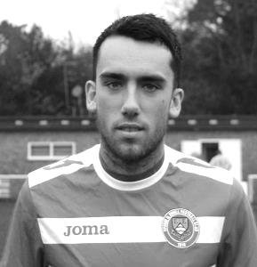
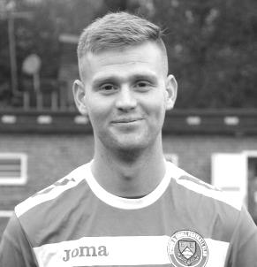
We have three birthdays to report in addition to Dale Marvell’s 35th birthday last Saturday.

Today is Matt Farrell’s 26th birthday, while on Monday Matt Ferdinando celebrates his 25th (pictured left and right).

It is also new boy Rhys North’s 28th birthday next Saturday. Have a good one chaps!

Cup Draws for 2015/16
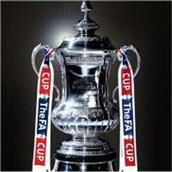
We face a real challenge in both the F.A.Cup and F.A.Vase this season.

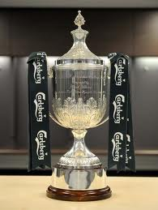
In the F.A.Cup we host Erith & Belvedere on Sunday 16th August. This is a very tough draw against a Southern Counties East (formerly Kent) League team that have recently been in the Ryman League and are keen to return there. They also reached the Quarter-Finals of the F.A. Vase last season, losing narrowly 2-0 to the eventual winners North Shields so we will have to be at our very best to get anything from this match. Should we progress though, the prize is a significant one as we would host our local friends Carshalton Athletic and with that game also having to take place on a Sunday it could provide our biggest attendance for many years.

Although we have played the Deres on 42 previous occasions dating back to the London League in 1929, we have never met in the F.A. Cup. We have met the Robins on 73 occasions with only Camberley Town having played us more, but have only met twice in the F.A. Cup, in 1934 and in 1960 with one win apiece. We last met in 2007 for a Surrey Senior Cup tie, but have not actually beaten them since 1955 which was 17 meetings ago!

In the F.A.Vase we face a trip to Sussex where we meet another team that lost their ground in Horsham. Recently relegated from the Ryman League this will be their first Vase tie since the late nineties and although we have met on 55 occasions dating back to 1957 we have never met in this competition. As with Erith I am sure they will be looking to bounce straight back, although they were relegated to Step Five for a reason and their attempts to find a new ground following the sale of the Queen Street ground around ten years ago have proven as frustrating as ours. The game will be played at Horsham YMCA’s Gorings Mead ground on Sunday 6th September.

If we defeat them we will face a trip to the scene of a daylight robbery from 2009, the High Street Ground, Selsey. We travelled down there in the F.A. Cup, yet despite their keeper being sent off after just 11 minutes and our domination of the game, they scored with a wind assisted long range deflected fluke goal. I’m not bitter, honest!

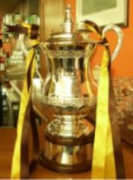
For some reason less rounds have been drawn in advance in both competitions this year, so we do not know who our opponents would be if we were to win two matches in either competition, but we’ll worry about that if it happens!
In the Surrey Senior Cup we do not yet know our opponents. Last season they did the draws live on BBC Radio Surrey and I hope they will do this again. Watch this space!

Finally, In the League Cup we have a bye to the Second round (last 32) where we have a local journey to our old stomping ground of Merland Rise to face Banstead Athletic. As always, this competition represents our best chance of progress.

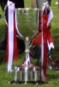
All in all, an interesting set of ties and an opportunity for progress if we can play well.

During the Break
Our Club Presentation took place on the Saturday 25th April at the Epsom Working Mens Club and it was a good day for Kyle Hough who picked up the Player of the Year Trophy, the Players Player of the Year Trophy and an award for reaching 300 appearances.

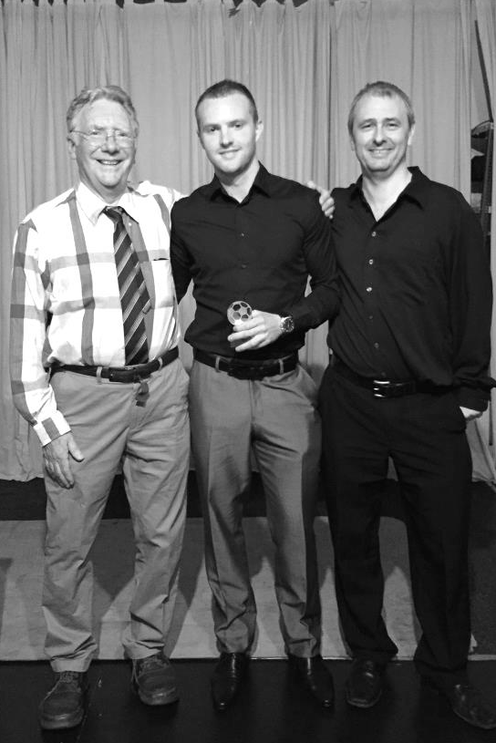
Additionally, James Taylor won the Managers Player of the Year Trophy, while Paul Marshall received the Clubman of the Year Trophy. Full pictures are available on the website, courtesy of Alex McKay.

Before you had time to rest we were back into pre-season, although many clubs started earlier and it will be interesting to see how well some of those clubs get on as the season stretches on.

We opened up our friendly schedule with a 2-2 draw against Banstead Athletic with Kyle Hough scoring twice and followed this with a 2-0 win over Sussex League Broadbridge Heath where the scorers were Savvas ‘Agi’ Panayiotou and James Kavanagh.

The third of our four matches at Surbiton Town was against Hoddesdon Town; our opponents 40 years ago in the Final of the F.A. Vase but this time with a different result as we defeated our Hertfordshire opponents 5-3, with two late goals for the visitors. Kyle scored another four with Matt Farrell scoring the fifth goal.

We then had to cancel our trip to St Francis Rangers on Saturday 25th July, but three days later we hosted Lingfield at Surbiton Town and gained a small measure of revenge for our Vase defeat last season with a 4-0 win. This time we had four different scorers and Dan Dean, Kyle Hough, Matt Farrell and Reisse Griffin found the net.

Then on Saturday we visited the Croydon Arena for a friendly with Croydon and with only eleven players fell to a 2-0 defeat after being goalless at half time.

Finally, we completed the pre-season with a convincing 2-1 win over our landlords Chipstead. It was a really good display and despite conceding just before the break, we turned it around with goals from Reisse Griffin and Kyle Hough.

Hopefully we can keep that sort of form going this afternoon!

Every Opponent A-Z
Over the years we have played many, many different opponents. Exactly how many is a difficult question, as it all depends on your definition. Are Camberley & Yorktown different to Camberley Town, or are Epsom Town different to Epsom F.C. or Epsom & Ewell F.C.?

In my analysis I have classed them as the same team, and will work through them all from A to Z. Some we have played many times, whilst others we have met just once or twice. Enjoy!


Nunhead: Played 7 - W3 D2 L2 - F15 A8 - PPG - 1.57 - Above Average

Many of you will never have heard of Nunhead Football Club, but they possessed a grand history. They were a very large club and were regular rivals of Dulwich Hamlet in those halcyon pre-war days. Indeed the two clubs played the very first match at the Hamlet’s Champion Hill ground in 1931 in front of a world record crowd for a League match between non-league clubs (that still exists) of 16,254. I’d be happy if we got the 254 here!!

They were founded as Wingfield House in 1899 before changing their name to Nunhead in 1904 and were Isthmian League Champions on two occasions in 1928/29 and 1929/30.

We first met on 5th March 1932, visiting their famous enclosure at Browns Ground where two second half goals from Harry Payton and George Mackesy enabled us to come away with a 2-2 draw in a Surrey Charity Shield Semi-Final. The replay took place some five weeks later on 13th April at West Street, although we were defeated 2-0.

The following season we were drawn together in the F.A. Cup, where in front of just under 2,500 at Nunhead we secured another replay with a goalless draw on Saturday 15th October 1932. Four days later we hosted the replay and destroyed them by five clear goals with three from Billy Williams and the others from Tommy Dunne and Reg Marlow. We were a good team back then but were still two leagues below the South Londoners, so this result was a massive surprise to all outside the Epsom area!

Certainly the following season when we were paired together in the same competition there was no fear of the supposed superior team and a hat trick from Leslie Marlow enabled us to cruise through 3-0 on our way to an eventual First Round meeting with Clapton Orient.

Our next meeting ended in defeat as we were beaten 3-0 at Browns Ground in the Surrey Senior Cup on Saturday 26th January 1935. The most interesting thing to note about this game in front of over 1,600 spectators was that one of the goals was scored by a young 16 year old player by the name of Denis Charles Scott Compton, who would go on to play for Arsenal and the full England team during war time, but would become even more famous in another sport as one of the greatest ever English cricketers. He along with Stanley Matthews set the ball rolling for lucrative player image rights when advertising Brylcreem back in the fifties!

Compton would have a great future ahead of him but matters were becoming more serious for Nunhead. They suffered a fire at the ground in 1936 but the damage was paid for by a local benefactor who was a Director of the club. However, the lease of the ground was running out and was due to expire in 1940 and this was causing concern as its renewal was looking unlikely.

We defeated them 5-1 in our final meeting; a Surrey Senior Cup Quarter Final at West Street on 12th February 1938 with goals from Tommy Rochester (2), Brian Beglan, Geoff Collins and Jimmy Jones, and just as the club were about to start their final season at Browns Ground, World War

Two was declared.

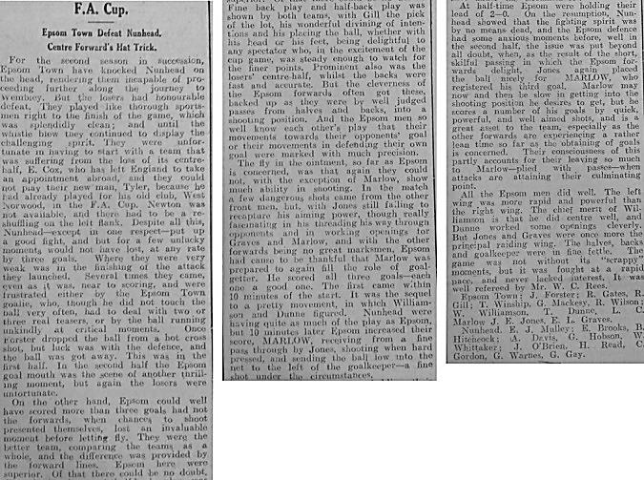
A new ground might have been achievable for the club if not for this wretched timing and to make matters worse, in 1940 the Director who had bailed them out previously was unable to do anything when his company premises received a direct hit in an early air raid, wiping his assets out with one cruel blow!

By this time, Nunhead were playing in a wartime league; the South Eastern Combination and our war time club Epsom Town met them at West Street in the Surrey Senior Cup, losing 3-1 on Saturday 2nd March 1940. For season 1940/41 they joined them in the Combination, although without a ground, Nunhead shared Champion Hill with old rivals Dulwich Hamlet and we finished even over the two league games with respective home wins for each team; 6-2 to us on 15th February 1941 and 1-0 to them seven days later.

But the armed forces call on players, along with the loss of the ground was too much and they called a halt to competitive fixtures in 1941. Although they continued to be F.A. members throughout the war, they finally admitted defeat and their Secretary Eric Mulley, who was also an excellent goalkeeper, wrote the letter advising their termination to the F.A. in 1949.

The irony of this is that Browns Ground might well have been built on, had it not been for the war, and it actually still survives today as a school field. I am told there remains a bit of terracing there but when I visited I was unable to access the site. What a pity that this Isthmian League giant of a club were unable to agree a new lease and became consigned to history after just sixty years.

An Epsom Herald match report showing our 3-0 F.A. Cup win from the 1933/34 season.

Centre page for results

Centre page for results



Windsor F.C. – History

Summer 2011 and it’s rather ironic that 100 years of senior football at Stag Meadow should be celebrated by the birth of a brand new club, Windsor FC, which came to be following the sad demise after 118 years of Windsor & Eton FC. During the final death throes of the previous club it became apparent, following several well attended supporters’ meetings, that the will was there to continue to host a senior football club in Windsor for the community to embrace and, therefore, on February 4th 2011 WFC Football Community Development Ltd was registered with Companies House with the aim of achieving that objective. Founding Director Kevin Stott and a newly-appointed management committee then set about the long and sometimes arduous task of turning that dream into a reality.

A business plan centred around self-sustainability was formulated and presented to the Football Association which eventually led to acceptance for the new club at level 5 of the non-league system and an allocation to compete in the Premier Division of the Cherry Red Records Combined Counties League for season 2011/12. Now the new club had been accepted it needed a name and invitations were extended to the people of Windsor to nominate and then vote on the new naming process and thus Windsor FC was born.

Self-sustaining and community are the two key elements behind the ethos of the new setup and the provision of a 3rd generation artificial surface training area/small-sided games pitches at the Great Park end of the ground, when completed, will form the foundations of the self-sustainability module as well as providing a much-needed facility for the community to use. The other main development thus far on the community side is welcoming on board the 34 teams and over 300 players of New Windsor Youth FC who will now be known as Windsor FC Youth, adopting the club badge and colours and providing a progression pathway from small-sided through to senior football for the youth of the town of Windsor.

One of our other innovative community involvement schemes sees our club mascot ‘Scotty the Stag’ regularly appearing at local school fetes and other events around the town publicising the club as well as supporting the fund raising activities of the club in general. In his spare time Scotty is becoming a bit of a celebrity taking part in races such as the Mascot Grand National and despite some close finishes is yet to claim his first win but if medals were given for effort then Scotty would be No.1 on the podium just for the amount of money he has raised for various local charities!

Our founding season turned out to be a very exciting one, eventually finishing as runners-up to worthy Champions Guildford City in the League. Several weeks into season 2012/13 a major decision to operate without a budget was taken to free up funds for the regeneration plans at the ground and the management team and all but three of the playing squad left immediately. Mick Woodham was appointed as our new manager and had two days to get together a squad before our next league game. Despite some heavy defeats early in his tenure as he built a squad of local youngsters the club never lost faith and Mick eventually put together a squad that was to finish a very creditable 6th in the league.

Recognition from the league away from football itself was achieved with a runners-up award for the programme in the Premier Division and FA Groundsman of the Year award for the CCL and this was added to in August 2013 when our groundsman Lewis Clements won the FA Groundsman of the Year Award for the whole of Step 5 and 6 football nationally. In October 2013 club secretary Steve Rowland attended the FA’s 150th Anniversary celebrations at Buckingham Palace where he was one of 150 people to receive a ‘Grassroots Hero’ award from HRH Prince William, something both he and the club are justifiably proud of whilst also giving some extra publicity to the CCL. In January 2014 the club announced a fantastic new sponsorship deal with local dealer Thames Motor Group with a new kit launch that featured in Four Four Two magazine and generated a lot of local publicity. Another interesting part of the deal sees two ‘wrapped’ Fiat 500’s displayed at the ground in the new home and away kit colours with special deals available for supporters to purchase cars in Windsor team colours which we believe to be a first in English football!

April 2014 saw the team pick up its first ever trophy when they defeated Hellenic League side Reading Town by 3 goals to 0 in the Final of the Berks & Bucks FA Senior and this was followed in April 2015 with a 3-2 victory against odds-on favourites Flackwell Heath to retain the trophy for a second year running.

Having lost a number of players during the close-season the team-building process will once again continue for season 2015/2016 as players are added to the squad with the emphasis on young local players interspersed with some older experienced heads and the further integration of players from our Reserve and U18’s teams will hopefully continue to reap rewards for us.

Cup Recaps 2014/15
EL Records Premier Challenge League Cup
Semi Finals
Colliers Wood United | 5-2+ | Farnham Town
Windsor | 1-2 | Camberley Town
Final @ Woking F.C. – Friday 1st May
Colliers Wood United | 1-2+ | Camberley Town

Surrey Senior Cup
Semi Finals
Molesey | 1-2 | Met Police
Merstham | 4-3 | Ashford Town (Mx)
Final @ Woking F.C. – Wednesday 6th May
Merstham | 0-2 | Met Police

F.A. Vase
Semi Finals – 1st leg - 21st March
Highworth Town | 0-1 | North Shields
AFC St Austell | 0-2 | Glossop North End
Semi Finals – 2nd leg – 28th March
North Shields | 3-0 | Highworth Town
Glossop North End | 0-1 | AFC St Austell
Final @Wembley Stadium – 9th May
North Shields | 2-1+ | Glossop North End
Northern League | 2-1+ | North West Counties

Club Statistical History - (up to date):
All League: Played: 2,795, Won: 1,140, Drawn: 529, Lost: 1,126
For: 5,124, Against: 4,985, GD: plus 139 - Win Ratio 40.79%

Combined Counties League only: Played: 374, Won: 166, Drawn: 71, Lost: 137
For: 658, Against: 599, GD: plus 59 - Win Ratio 44.39%

Cup and Other: Played: 1,092, Won: 518, Drawn: 127, Lost: 439
For: 2,374, Against: 2,038, GD: plus 336 - Win Ratio 47.44%

Abandoned Matches: Played: 8: For: 14, Against: 16

Under Glyn Mandeville: Played 39, Won: 20, Drawn: 2, Lost: 17
For: 77, Against: 71, GD: plus 6 - Win Ratio 51.28%

Overall Total: Played 3,887, Won: 1,658, Drawn: 656, Lost: 1,565, Abandoned: 8
For: 7,498, Against: 7,023, GD: plus 475 - Win Ratio 42.66%

Scouting the Opponent – Erith & Belvedere
Erith & Belvedere are our opponents next Sunday in the F.A. Cup. I won’t mince my words, this is a tough tie!

They won the Kent League in its final season 2012/13 before it was renamed, but struggled in the Ryman League and dropped straight back. They made a fine attempt to rebound last season but surprise package Phoenix Sports headed them all the way and at the end of the season they were just caught by Ashford United too.

Despite that disappointment, they still reached the Quarter-Final of the F.A. Vase last season, narrowly losing to eventual winners North Shields and probably have that competition in their sights again this year, so without a doubt they will be a good side and we will have to be at our very best to get through this tie. Can we do it? Of course we can!

They also have a very unusual home arrangement. Since losing their old ground at Park View they have shared Welling United’s ground at Park View Road on an equal basis with their stands on one side of the ground (pictured) while the Wings face them on the other side! (© David Bauckham).

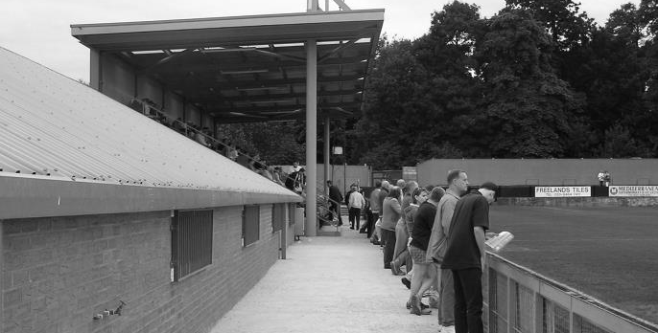

Southern Counties East League - Final Table 2014/15
 | P | W | D | L | F | A | Pts | GD
Phoenix Sports | 38 | 28 | 9 | 1 | 94 | 20 | 93 | +74
Ashford United | 38 | 25 | 10 | 3 | 96 | 39 | 85 | +57
Erith & Belvedere | 38 | 25 | 7 | 6 | 83 | 36 | 82 | +47
Greenwich Borough | 38 | 22 | 8 | 8 | 88 | 49 | 74 | +39
Tunbridge Wells | 38 | 19 | 9 | 10 | 74 | 51 | 66 | +23
Corinthian | 38 | 19 | 2 | 17 | 78 | 67 | 59 | +11
Cray Valley (PM) | 38 | 16 | 10 | 12 | 77 | 63 | 58 | +14
Sevenoaks Town | 38 | 15 | 10 | 13 | 68 | 61 | 55 | +7
Beckenham Town | 38 | 16 | 5 | 17 | 77 | 63 | 53 | +14
Crowborough Athletic | 38 | 14 | 7 | 17 | 62 | 78 | 49 | -16
Woodstock Sports | 38 | 14 | 6 | 18 | 45 | 60 | 48 | -15
Canterbury City | 38 | 14 | 5 | 19 | 50 | 69 | 47 | -19
Deal Town | 38 | 14 | 4 | 20 | 66 | 78 | 46 | -12
Holmesdale | 38 | 11 | 7 | 20 | 74 | 90 | 40 | -16
Lordswood | 38 | 10 | 9 | 19 | 43 | 77 | 39 | -34
Fisher | 38 | 10 | 8 | 20 | 49 | 79 | 38 | -30
Lingfield | 38 | 12 | 2 | 24 | 76 | 129 | 38 | -53
Croydon | 38 | 10 | 5 | 23 | 40 | 70 | 35 | -30
Erith Town | 38 | 9 | 7 | 22 | 48 | 84 | 34 | -36
Rochester United | 38 | 9 | 6 | 23 | 57 | 82 | 33 | -25

CCL Premier Division Club Directory
A.F.C. HAYES Telephone: 0208-845-0110 - Ground: Farm Park, Kingshill Avenue, Hayes, Middx. UB4 8DD - Colours: Blue and White Stripes/Blue/Blue

ASHFORD TOWN (Mx) Telephone: 01784-245908 - Ground: The Robert Parker Stadium, Short Lane, Stanwell, Middx. TW19 7BH - Colours: Tangerine & White Stripes/Black/Tangerine

BADSHOT LEA Telephone: 01252-320385 - Ground: Ash United FC, Shawfield Stadium, Youngs Drive, Shawfields Road, Ash, Hampshire. GU12 6RE - Colours: Claret/White/Claret

BEDFONT SPORTS Telephone: 0208-831-9067 - Ground: Bedfont Sports Club, Hatton Road, Bedfont, Middx TW14 8JA - Colours: Red & Black Hoops/Black/Red & Black Hoops

CAMBERLEY TOWN Telephone: 01276-65392 - Ground: Krooner Park, Wilton Road, Camberley, Surrey. GU15 2QW - Colours: Red & White Stripes/Blue/Red

CHERTSEY TOWN Telephone: 01932-561774 - Ground: Alwyns Lane, Chertsey, Surrey. KT16 9DW - Colours: Royal Blue & White Stripes/Royal Blue/Royal Blue

CHESSINGTON & HOOK UNITED Telephone: 01372-602263 - Ground: Chalky Lane, Chessington, Surrey. KT9 2NF - Colours: Blue/Blue/Blue

COLLIERS WOOD UNITED Telephone: 0208-942 8062 - Ground: Wibbandune Sports Ground, Robin Hood Way, Wimbledon. SW20 0AA - Colours: Blue & Black Stripes/Black/Black

COVE Telephone: 01252-543615 - Ground: Oak Farm Fields, 7 Squirrel Lane, Cove, Farnborough, Hampshire. GU14 8PB - Colours: Yellow/Black/Yellow

EPSOM & EWELL Telephone: 01737-553250 - Ground: Chipstead FC, High Road, Chipstead, Surrey. CR5 3SF - Colours: Royal Blue & White Hoops/Royal Blue/Royal Blue & White Hoops

FARNHAM TOWN Telephone: 01252-715305 Ground: Memorial Ground, Babbs Mead, West Street, Farnham, Surrey. GU9 7DY Colours: - Claret & Sky Blue /White/ Claret & Sky Blue

GUILDFORD CITY Telephone: 01483-443322 - Ground: The Spectrum, Parkway, Guildford, Surrey. GU1 1UP - Colours: Red & White Stripes/Black/Black

HANWORTH VILLA Telephone: 0208-831-9391 - Ground: Rectory Meadows, Park Road, off Hounslow Road, Hanworth, Middlesex. TW13 6PN - Colours: Red & White Stripes/Black/Black

HARTLEY WINTNEY Telephone: 01252-843586 - Ground: Memorial Playing Fields, Green Lane, Hartley Wintney, Hants RG27 8DL - Colours: Orange & Black/ Orange /Orange

HORLEY TOWN Telephone: 01293-822000 - Ground: The New Defence, Anderson Way, Court Lodge Road, Horley, Surrey. RH6 8SP - Colours: Claret & Sky Blue/Claret/Claret

KNAPHILL Telephone: 01483-475150 - Ground: Brookwood Country Park, Redding Way, Lower Guildford Road, Knaphill, Surrey. GU21 2AY - Colours: Red/Black/Red

MOLE VALLEY SCR Telephone: 01932-866386 - Ground: Cobham FC, Leg O’Mutton Field, Anvil Lane, Downside Bridge Road, Cobham, Surrey KT11 1AA - Colours: Yellow/Black/Black

RAYNES PARK VALE Telephone: 020-8540-8843 - Ground: Prince Georges Playing Field, Grand Drive, Raynes Park, London. SW20 9NB - Colours: Blue/Blue/Red

REDHILL Telephone: 01737-762129 - Ground: Kiln Brow, Three Arch Road, Redhill, Surrey RH1 5AG - Colours: Red and White Stripes/Black/Red

SPELTHORNE SPORTS Telephone: 01932-961055 - Ground: Spelthorne Sports Club, 296 Staines Road, Ashford Common, Ashford, Middx. TW15 1RY - Colours: Light & Dark Blue/Dark Blue/Light Blue

WESTFIELD Telephone: 01483-771106 - Ground: Woking Park, Kingfield Road, Woking, Surrey. GU22 9BA - Colours: Yellow/Black/Black

WINDSOR Telephone: 01753-860656 - Ground: Stag Meadow, St Leonards Road, Windsor, Berks SL4 3DR - Colours: Red/Red/Red

Epsom & Ewell F.C. Club History 1918 - 2015

We were founded in March 1918 as Epsom Juniors Cricket Club and played throughout the summer. In the autumn, Epsom Juniors F.C. came into being and played a handful of games from what is now known as Alexandra Recreation Ground. Competitive football followed as we entered the Surrey Junior League in 1919, and became founder members of the Sutton & District League in 1920.

A change of name in July 1922 to Epsom Town F.C. heralded the start of a very successful era. By now resident at the Horton Hospital Sports Ground, we were unfortunate to lose 2-1 after extra time at Dorking F.C.’s Pixham Lane ground to Caterham Mental Hospital in a replay of the Surrey Junior Cup Final. However, we won three other trophies that season, the Leatherhead Hospital Shield, the Sutton Hospital Cup, and the Epsom Hospital Cup. In addition, we also won the Sutton & District League, and under the forward thinking of their visionary Chairman Hugh Bradley, took the step into Intermediate Football, where we won the Southern Suburban League without losing a match. Senior football was granted as we were unanimously accepted into the Surrey Senior League for 1924/25, where we finished third.

In September 1925, the club relocated to the old Ewell F.C. ground at West Street, which was purchased through the generosity of our future President Robert Bradshaw. In 1925/26 the Championship of the Surrey Senior League was attained, and the following season, we defeated Egham 1-0 at Egham in the League Charity Cup to complete a League and Cup “double”.

Election to the London League followed, and the title was claimed in the first attempt in 1927/28. Unfortunately, we were unable to repeat this, instead finishing runners-up in 1931/32, 1932/33, 1934/35, 1936/37 and 1937/38. Cup Honours were limited, although in 1929 Redhill defeated us 3-2 in front of 4,600 at Guildford in our first Surrey Senior Cup Final, having seen off Wimbledon 4-1 in the semi-final!

The thirties were a very successful era, and we won the Surrey Charity (Senior) Shield in 1933 with an impressive 5-0 win over Woking at Kingfield. However, the proudest moment of our pre-war history was an appearance in the First Round Proper of the F.A.Cup in 1933/34. Woking, Nunhead, Tooting & Mitcham, Beddington Corner, and Leytonstone were defeated, and a crowd of 9,485 at the Lea Bridge Speedway Stadium witnessed a 4-2 loss against the hosts Clapton Orient. At the end of that season we changed our name to Epsom F.C.

In 1939 a newly formed team, Epsom Town (no connection to the earlier name) shared the ground with Epsom F.C. However, this arrangement was suspended when war was declared, and we folded for the duration. In the meantime, Club Chairman Charles Pettett threw in his lot with Epsom Town in an attempt to boost morale by keeping the football flag flying. It was successful, as that club competed continuously throughout the war years, winning the Surrey Combination in 1939/40, and reaching the Surrey Senior Cup Final in 1944, losing 3-1 to Tooting & Mitcham, at Sandy Lane. After the war, Epsom F.C. restarted, continuing in the London League and reclaimed West Street. Temporary homes were found for Epsom Town while they competed for a season in the newly created Corinthian League, but disbanded in 1946.

In 1949 we entered the Corinthian League ourselves, where in 1952 we reached the League Memorial Shield Final in 1952, going down 2-1 to Champions Hounslow at Eastbourne after leading at half-time. Things improved further with the signing of the former English Amateur International Pat Lynch from Hendon, finishing third in 1952/53, while in 1954 we reached the Surrey Senior Cup Final for the second time in our history, losing unluckily 2-0 to Corinthian Casuals in front of 6,159 at Selhurst Park. In 1955 we won the Surrey Senior Shield with a 1-0 win over Carshalton Athletic at West Street.

We appointed our first ever Manager, Kingstonian legend Doug Whitehead in 1955 and the Corinthian League double was almost achieved in 1956/57, but two losses in the final week, along with a 2-0 defeat in the Cup Final to Maidenhead United at Dorking ensured that we ended with neither, finishing fourth. However in 1960, we finally raised the Shield with a 2-0 revenge win over Maidenhead at Vale Farm, home of Wembley F.C.

In 1960 we changed our name once again to Epsom & Ewell F.C. This was not because of any merger with Ewell & Stoneleigh as is often quoted, but was an attempt to increase support across the whole of the Borough. In 1963 the Corinthian League merged with the Athenian and Delphian Leagues, and we were placed in Division One of the new structure, but the sixties were full of poor results and we were relegated in 1965.

Despite a string of managers, most notably ex-Leyton Orient winger Jimmy Smith, and Tony Williams, now famous for his creation of the F.A. Yearbooks, our fortunes did not improve significantly and further relegations were avoided in the early seventies by the benefit of re-election. However in 1973, despite “improving” to finish second from bottom, the Athenian League ran out of patience and cut us loose. This was unfortunate timing as

we had just cleared all of our debts, and in addition to a virtually new Committee, former Fulham player Pat O’Connell had taken over as Manager.

The Surrey Senior League took us in at the last minute, and the new squad, including young striker Tommy Tuite, won the League Cup, and the following season, 1974/75 achieved a second Surrey Senior League “double”. However, the season would always be remembered for reaching the Final of the inaugural F.A. Vase, where 9,500 saw the Blues edged out 2-1 by Hoddesdon Town at Wembley Stadium. The Athenian League welcomed us back, and promotion to the top flight was achieved in that first season. In 1976/77 we reached the Athenian League Cup Final, losing 1-0 at Chalfont St Peter.

For 1977/78 many clubs were invited to join the expanding Isthmian League, and we were placed in the new Division Two. Our first match under floodlights took place against Met Police, and the title was clinched the following April. In 1979/80 we won the Southern Combination Cup 7-2 over Hampton on their own pitch, where the opposition were blitzed by five goals from Tuite. The following season a new clubhouse opened at West Street, and we finally won the Surrey Senior Cup, defeating Woking 2-1 at Tooting & Mitcham, although we just missed out on promotion. In 1983/84 we clinched a spot in the Premier Division as runners-up, although this time we missed out in the Surrey Senior Cup Final, defeated 4-0 by Sutton United at Imber Court.

With Adrian Hill as Manager since 1982, we survived comfortably in our first season at the new level, but Hill’s departure to Croydon in 1985 started a decline. Much of the squad left with Hill, and new Manager Alan Webb had too much to do. We were relegated in 1986, and following Webb’s departure soon after, Player / Manager Ricky Kidd nearly but not quite saved us from our second straight relegation. Adrian Hill replaced Kidd for a second spell at the helm in 1990, but we were placed in the new Division Three in 1991 in league reorganisation following a finish one position below the required half way mark.

In 1993 a large chapter in our history ended as we left West Street and moved in as tenants of Banstead Athletic. The decade was largely one of frustration, although we did reach the Final of the Associate Members Trophy, losing 2-0 to Bedford Town at Hendon’s old Claremont Road ground.

In 2002 Adrian Hill took us back up to Division 1 South, where we topped the table for a month, eventually finishing 9th, but Hill’s retirement at the end of the season led to relegation a year later and in 2006 we were transferred into the Combined Counties League Premier Division. In October 2006 Lyndon Buckwell, a former player became our new Manager, and in his first full season (2007/08) we were back in the top ten. In 2008/09 we exceeded this achievement and finished in fourth place after heading the table for a few months. In 2009/10 the club recovered from a slow start to finish fifth and also reached the last 32 of the F.A. Vase for the first time in 21 years, bowing out 3-2 in Northamptonshire to Long Buckby. In April of 2010 we terminated our seventeen-year ground sharing agreement with Banstead Athletic and spent two unspectacular seasons at Merstham F.C. before relocating to High Road, home of Chipstead F.C. for the 2012/13 season.

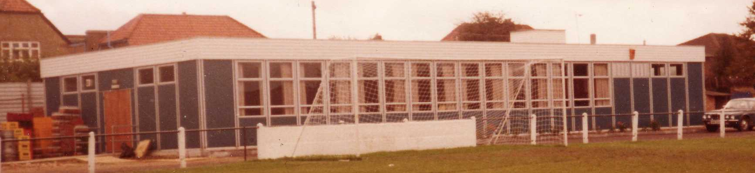
The season brought significant playing success as a slow start was followed by a spectacular run of form, including a club record 12 straight League wins, which put us at the top of the table for over a month before a tough run in resulted in a final position of fifth. However, any disappointment there was tempered by the club’s first silverware since 1981 when we defeated South Park 3-0 at Farnborough to win the Combined Counties League Cup. Lyndon also marked 300 games in charge of the club in early 2013. On a sadder note, 2012/13 also marked one thousand games and twenty seasons since we left West Street.

We carried our fine form into 2013/14 and led the league with eight straight wins but couldn’t hold on and had to settle for third place, our highest league finish since 1984, but the following season Lyndon Buckwell departed and Glyn Mandeville and new Assistant Matt Smith steered the club to seventh place, despite a substantial budget cut. and we continue at High Road for 2014/15.

Meanwhile, the search continues for a new ground back in the Borough…..

Player Sponsorship
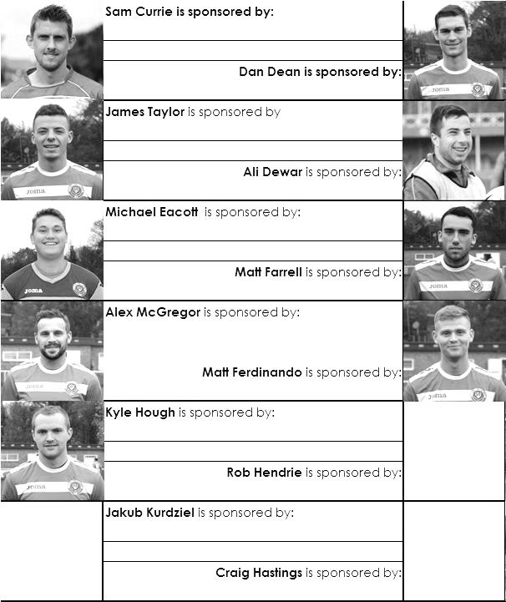

Here is the opening list of the season showing all of our players and Management that are currently available for sponsorship this season. Pictures for our new players will feature shortly.

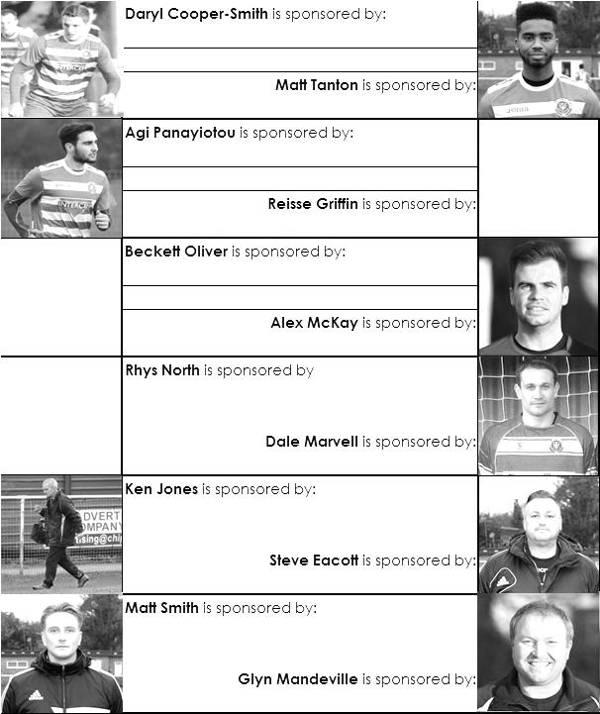
Sponsorship costs just £40 and it is easy to do. Just select a player who has not been previously sponsored and let a Committee Member know that you would like to sponsor them. Beware though. Until we have received the money it is possible for someone to jump in front of you, so don’t delay, act today!

Match and Ball Sponsorships – 2015/16
Opponent | Date | Match Sponsor | Ball Sponsor
Hoddesdon Town | 18/07/15 | Geoff Dyke
Windsor | 08/08/15 | Club President Stella Lamont
Erith & Belvedere | 16/08/15 | Mike Lovett
Colliers Wood United | 18/08/15 | Provisional - if no F.A. Cup replay
Carshalton Athletic | 30/08/15 | Provisional - Only if we defeat Erith & Belvedere
Raynes Park Vale | 31/08/15 | or 01/09/15 if we defeat Erith & Belvedere and even then, all dependent on not having an F.A. Cup replay
AFC Hayes | 19/09/15
Farnham Town | 26/09/15
Chertsey Town | 17/10/15
Chessington & Hook United | 07/11/15
Hanworth Villa | 21/11/15
Guildford City | 05/12/15
Cove | 08/12/15
Sutton Common Rovers | 19/12/15
Redhill | 02/01/16
Spelthorne Sports | 16/01/16
Hartley Wintney | 30/01/16
Bedfont Sports | 13/02/16
Horley Town | 27/02/16
Knaphill | 12/03/16
Westfield | 26/03/16
Badshot Lea | 09/04/16
Camberley Town | 16/04/16
Ashford Town (Mx) | 30/04/16
For League, League Cup and Surrey Senior Cup Matches:

Match sponsorship - £40.00 Match ball sponsorship - £25.00.
Combined Offer of Match and Match Ball sponsorship for £55.00.

For F.A. Cup and F.A. Vase matches:

Match sponsorship - £50.00 Match ball sponsorship - £30.00.
Combined Offer of Match and Match Ball sponsorship for £65.00.
----------------------------------------------------------------------------------------------------------------------------
Sponsorship includes: (x2 for match, x3 for match and ball)

Admission, programmes, hospitality and advertising and mascot for the day (if required).

If you are interested, just speak to a Committee Member, you know where we are!
Alternatively, drop me an email at: richard.c.lambert@gmail.com

Salts Super Six Predictor
The Salts Super Six Predictor is live again for the first time this season. The tickets are on sale at today’s game to the left of the gate.

The competition is easy to play and you don’t even have to be at the match! To win, you simply need to predict the results of six matches correctly from the three options, fill in the form and make sure it is back with one of our distributors before the deadline on the ticket. The latest fixtures are shown here.

If you are a club regular, you just need to place your name on the sheet, although if you aren’t, then we’ll need a contact number from you too. We will announce any winners on the website within three working days, so don’t worry, we won’t miss you!

We had a big jackpot winner last year and who knows how much could be won this time! It is currently £50 and you’ll always know the size of the pot before you enter.

Please note that if there is more than one winner, the prize pot would be shared between the winners. All you need to do now is have a go, as many times as you like!

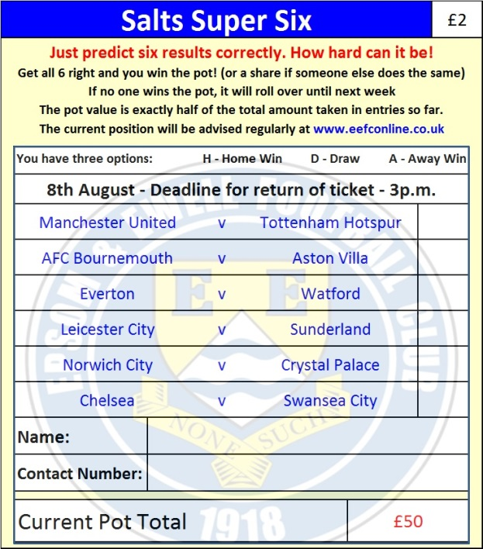

Good luck!

Combined Counties League – Premier Division
Saturday, 8th August 2015 - Kick-off 3.00 p.m.
Epsom and Ewell  (Royal Blue & White hoops) | V |  | Windsor  (Green with Red & White Trim)
Squad | NUMBERS
Michael Eacott |  |  | Carl Dennison
© Sam Currie |  |  | Jake Jenkins
Matt Tanton |  |  | Adam Kirby ©
Dale Marvell |  |  | Lewis Leonetti
James Taylor |  |  | Jamie Di Guiseppe
Dan Dean |  |  | Chris Dean
Matt Farrell |  |  | Tyeone Godwyn
Reisse Griffin |  |  | Ian Gosling
Kyle Hough |  |  | Amin Khomsi
Daryl Cooper-Smith |  |  | Eddie Lazarczuk
Matt Ferdinando |  |  | Kyle Lucas
Craig Hastings |  |  | Omar Riaz
Beckett Oliver |  |  | Owen Richardson
Jakub Kurdziel |  |  | Jason Sheehan
Rhys North |  |  | Levi Thackery
Savva ‘Agi’ Panayiotou |  |  | Riccardo Cannon
Alex McKay |  |  | Wayne Harvey
Rob Hendrie |  |  | Stanley Mugisha
Alex McGregor |  |  | Adam Turner
Glyn Mandeville | MANAGER |  | Mick Woodham
Matt Smith | ASSISTANT |  | Tony Thompson
Steve Eacott / Alex McKay | COACHES
REFEREE: A.Lashchikov (London)
ASSISTANTS: K.Corrick (Oxted), L.Gordon (Wallington)
Today’s Match and Ball are sponsored by
our Club President Stella Lamont

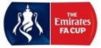
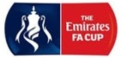
OUR NEXT VISITORS TO HIGH ROAD
Erith & Belvedere
*Sunday* 16th August 2015 - Kick-off 3.00 p.m.
The Emirates F.A. Cup – Extra-Preliminary Round

